SOCIALIST REPUBLIC OF VIETNAM
Independence - Freedom – Happiness
No.: 102

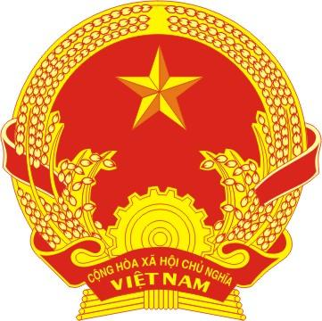

CERTIFICATE OF MARRIAGE

Name and surname of Wife: |  | Name and surname of Husband:
Date of birth: |  | Date of birth:
Ethnic group: |  | Ethnic group:
Nationality: |  | Nationality:
Permanent residence: |  | Permanent residence:
Identity Card/Passport: issued by on |  | Identity Card/Passport: issued by on
Registered at People’s Committee of
Registered on
Wife's signature  (Signed)  Nguyen Thi B |  | Husband's signature  (Signed)  Nguyen Van A
FOR PEOPLE'S COMMITTEE OF THE WARD
CHAIRMAN
(Signed and sealed)

